**JAVA PROGRAM 1:**

**write a java Program to print smallest and biggest possible palindrome word in a given string.**

public class Main

{

public static boolean isPalindrome(String a)

{

boolean flag = true;

for(int i = 0; i < a.length()/2; i++){

if(a.charAt(i) != a.charAt(a.length()-i-1)){

flag = false;

break;

}

}

return flag;

}

public static void main(String[] args)

{

String string = "Wow you own kayak";

String word = "", smallPalin = "", bigPalin="";

String[] words = new String[100];

int temp = 0, count = 0;

string = string.toLowerCase();

string = string + " ";

for(int i = 0; i < string.length(); i++)

{

if(string.charAt(i) != ' ')

{

word = word + string.charAt(i);

}

else

{

words[temp] = word;

temp++;

word = "";

}

}

for(int i = 0; i< temp; i++)

{

if(isPalindrome(words[i]))

{

count++;

if(count == 1)

smallPalin = bigPalin = words[i];

else

{

if(smallPalin.length() > words[i].length())

smallPalin = words[i];

if(bigPalin.length() < words[i].length())

bigPalin = words[i];

}

}

}

if(count == 0)

System.out.println("No palindrome is present in the given string");

else

{

System.out.println("Smallest palindromic word: " + smallPalin);

System.out.println("Biggest palindromic word: " + bigPalin);

}

}

}

**OUTPUT:**

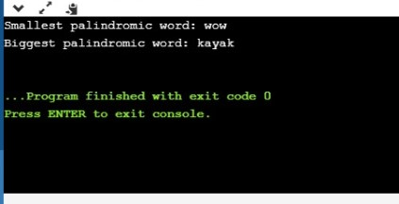

**PYTHON PROGRAM 2:**

Print a list of first and last 5 elements where the values are square of numbers between 1 and 30.

def printValues():

l = list()

for i in range(1,21):

l.append(i**2)

print(l[:5])

print(l[-5:])

printValues()

**OUTPUT:**

